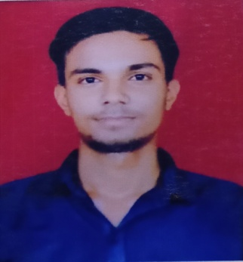

**AJAY KUMAR**

Address: F2/695, SANGAM VIHAR, NEW DELHI- 110062

E-mail: *ajaykumar23aps@gmail.com*

Phone: +91 7678640805

LinkedIn: https://www.linkedin.com/in/ajay-kumar-aa97781ab/

**PROFESSIONAL SUMMARY**

A well-organized, creative and goal-oriented graduate possessing excellent communication, problem-solving and leadership skills with a flair to explore suitable avenues in Computer Science Engineering while developing advanced projects with efficiency and quality.

**TECHNICAL COMPETENCIES**

C++ | JAVA | WEB DEVELOPMENT | MYSQL | DATA ANALYSIS| REACT

  

**INTERPERSONAL SKILLS**

Team Leadership **|** Management & Coordination **|** Decision Making

**INTERESTS & HOBBIES**

Coding **|** TRAVELLING**|** Music

**LANGUAGES KNOWN**

English **|** Hindi

**PERSONAL DETAILS**

Mother’s Name: REKHA DEVI

Father’ Name:

KRISHNA LAL

D.O.B.: 18-02-2000

**EDUCATION**

Bachelors in Computer Science Engineering | Chandigarh University, Gharuan

*Session: 2019-2023 | Score: 7.56 CGPA*

Intermediate (CBSE) |Sarvodaya Vidyalaya(Rani Durgawati), Delhi

*Session: 2017-2018 | Percentage: 59.6%*

Matriculation (CBSE) | Amrita Public School, Delhi

*Session: 2015-2016 | Percentage: 79.8%*

**TRAINING & PROJECTS**

**EMPLOYEE WORK MONITORING SYSTEM**

October 2021-November 2021

* A simple employee monitoring and time tracking tool aimed squarely at small to midsize businesses. Admin can get the details of employees.

**e-LEARNING WEBSITE**

April 2021-May 2021

* A website based on HTML, CSS and JavaScript which sorts some of the best courses available on various e-learning websites.

**PAYMENT DATE PREDICTION (ML MODEL)**

JANUARY 2022-APRIL 2022

* Get a prediction of when the invoice is getting to get paid.

**AI-ENABLED FINTECH B2B INVOICE MANAGEMENT APPLICATION**

JANUARY 2022-APRIL 2022

* Full-Stack Invoice Management Application uisng ReactJs, JDBC,Java,Servlets.

**WORK EXPERIENCES**

* **HIGH RADIUS CORPORATION, Intern**

JANUARY 2022-APRIL 2022

Worked on Full Stack Web Application

Get a prediction of when the invoice is getting to get paid.

We can Add, Edit, Delete and Update the buyers as per our needs.

**CERTIFICATIONS & AWARDS**

* Complete Python Bootcamp from Zero to Hero from UDEMY
* Machine Learning by Stanford University from COURSERA
* Web Development Bootcamp from UDEMY
* React from INTERNSHALA

**EXTRA CURRICULAR & CO-CURRICULAR ACHIEVEMENTS**

* Received awards in various inter college Competition, relating to activities such as Debate competition, Chess & Cricket.
* Participated in various coding challenges.